**Dashboards and Story using Tableau**

**Connect to Data**

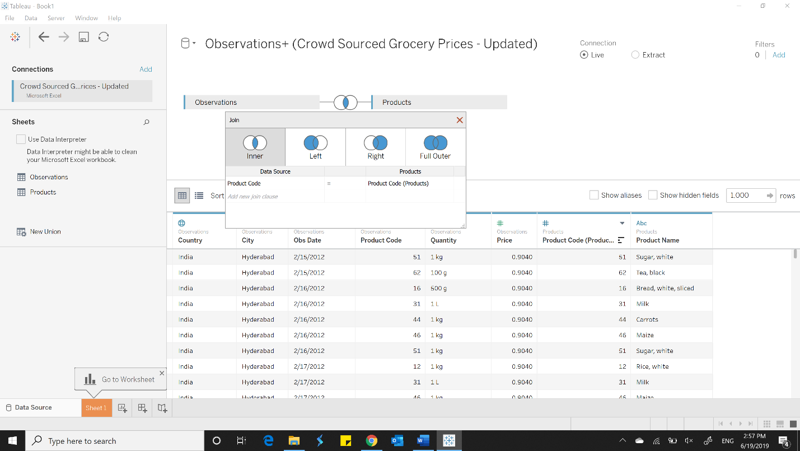

**Plot countries as a map**

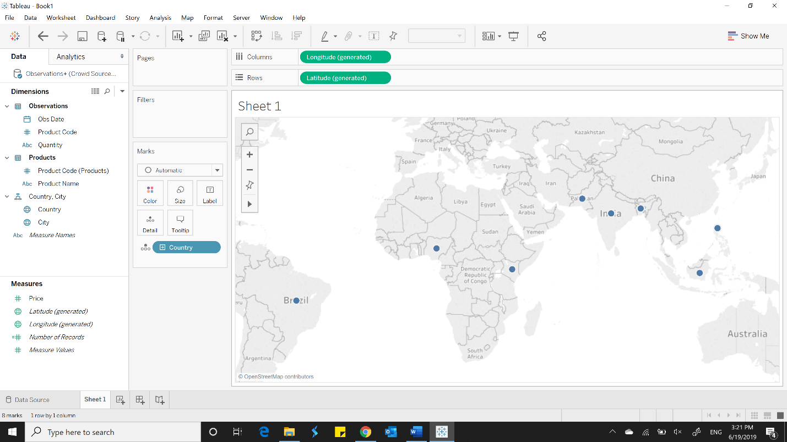

**To analyze Which country has the most expensive average price**

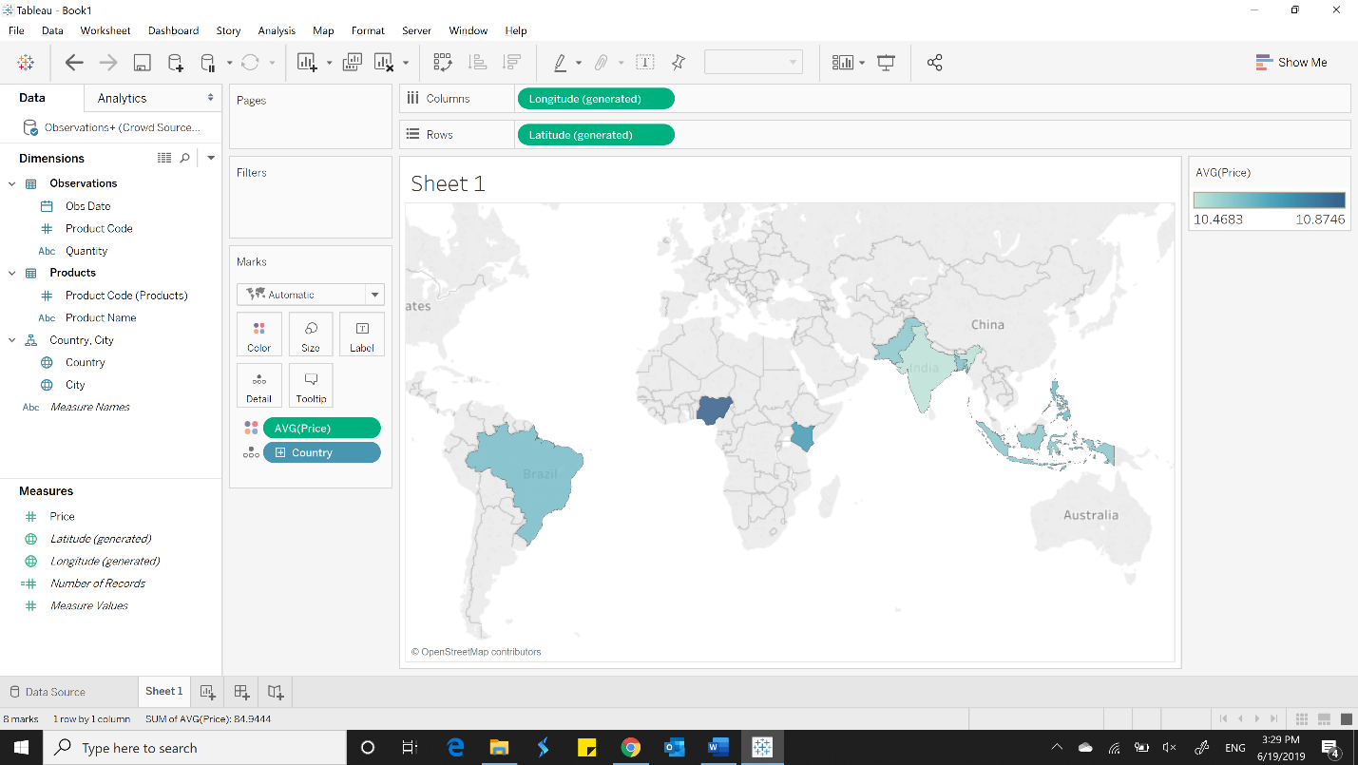

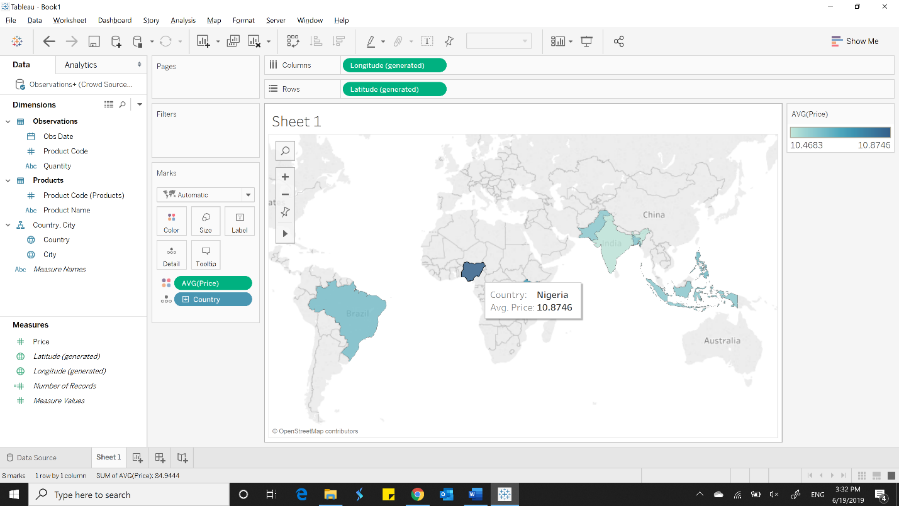

**Make a filled map of countries**

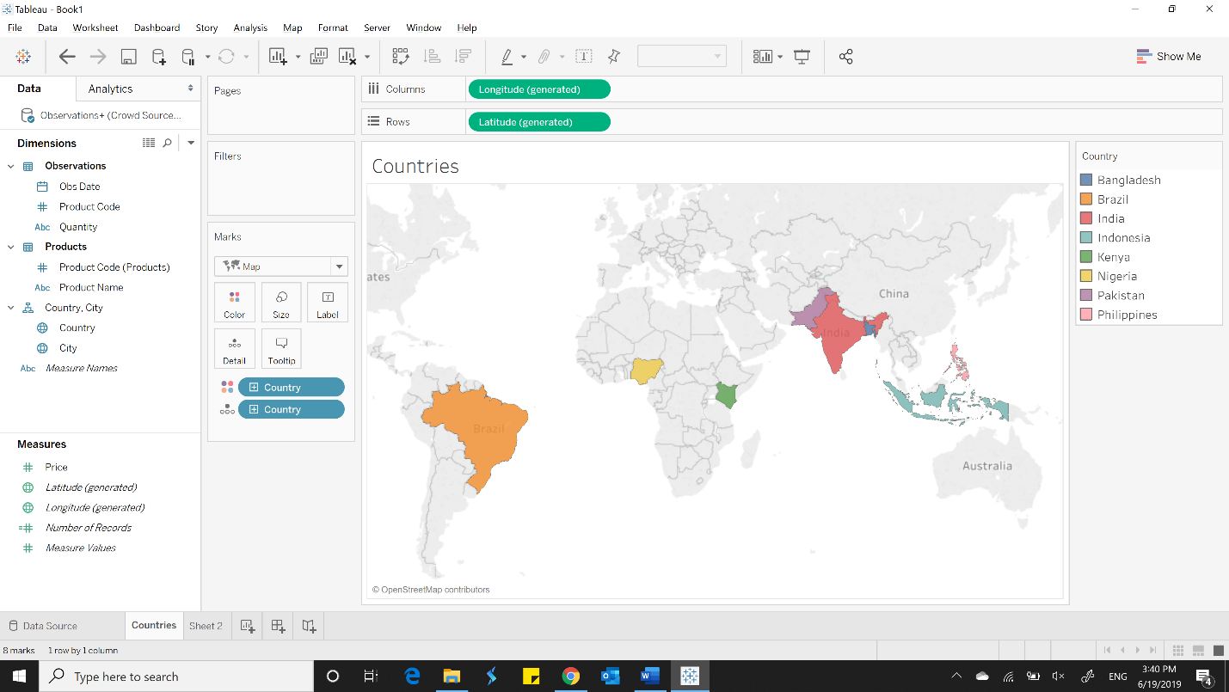

**To analyze how much variation is there in product prices across each country throughout the 4 years**

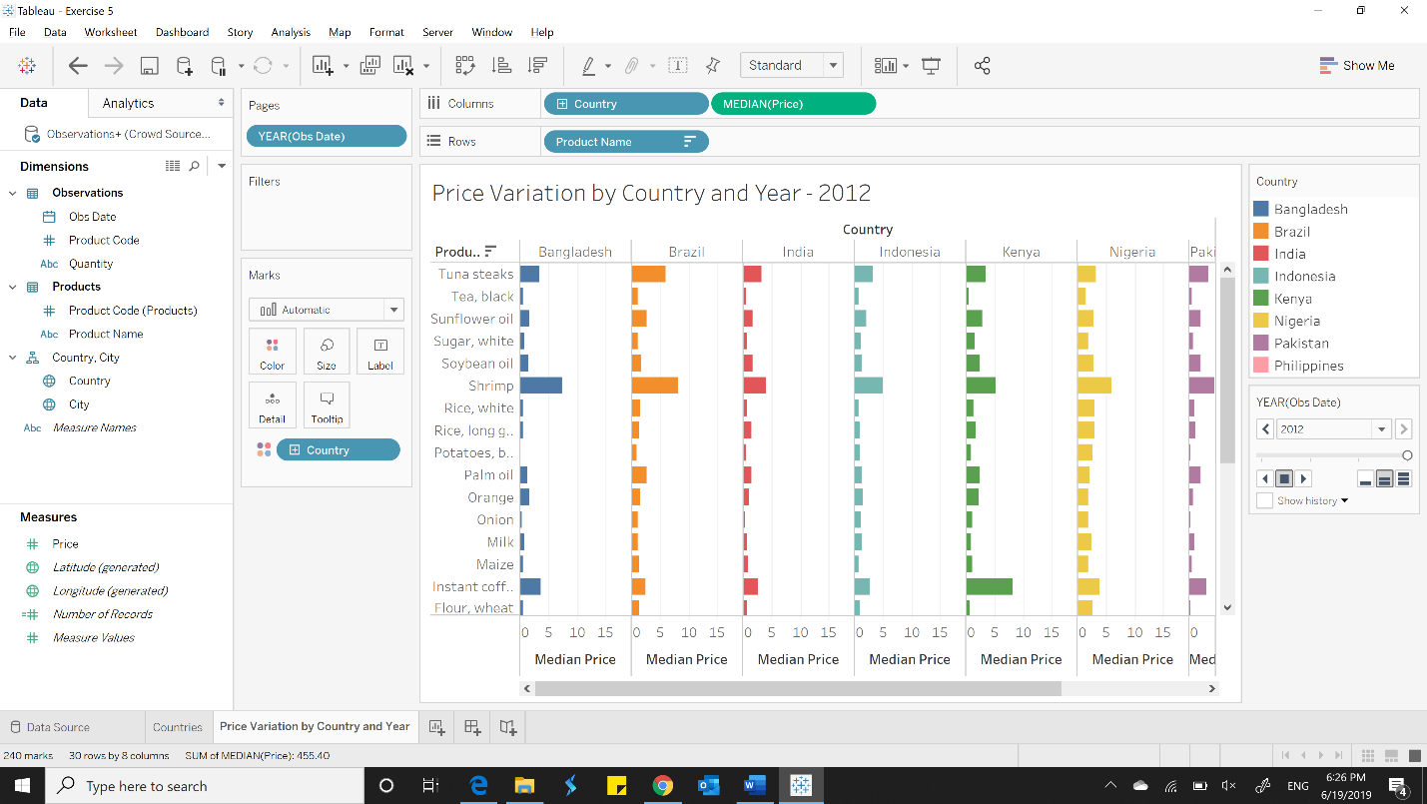

**To analyze how much variation is there in product prices across each country**

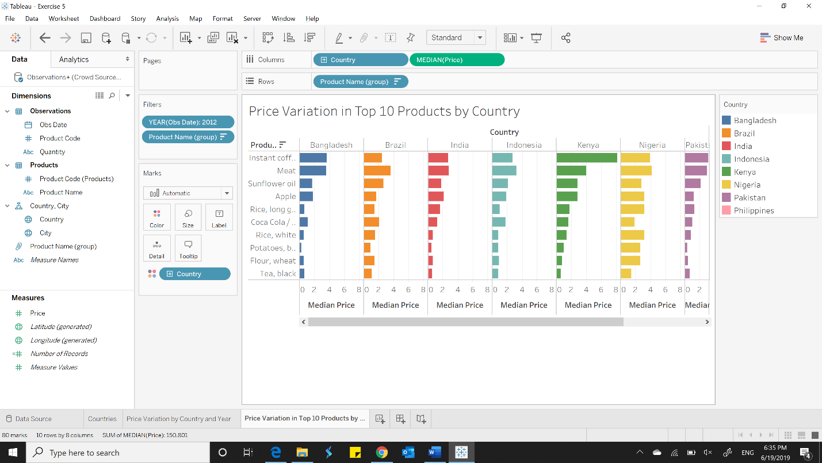

**Create a story and add a point with description**

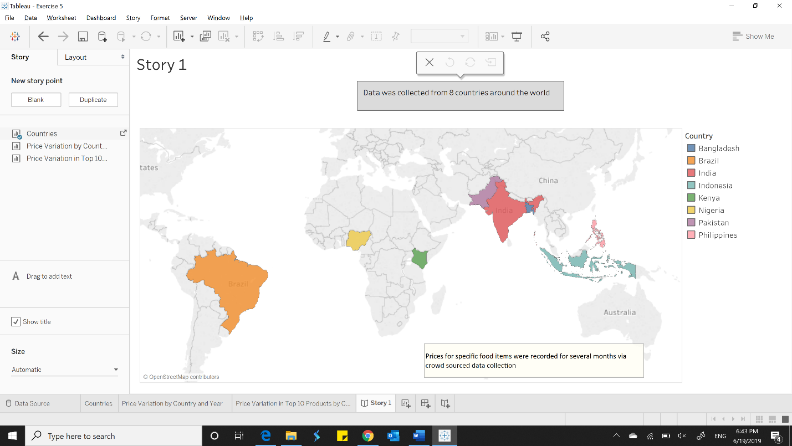

**Showcase interactivity and saving a specific state of a visualization**

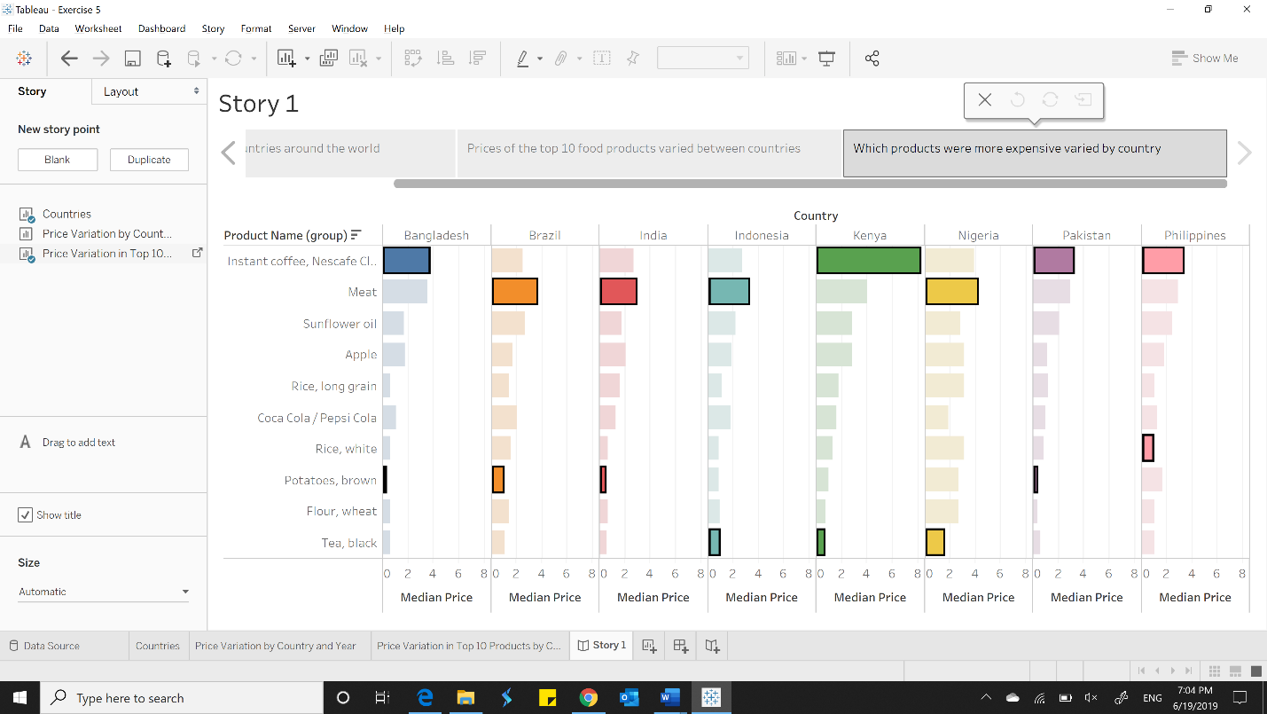

**Dashboards and Stories**

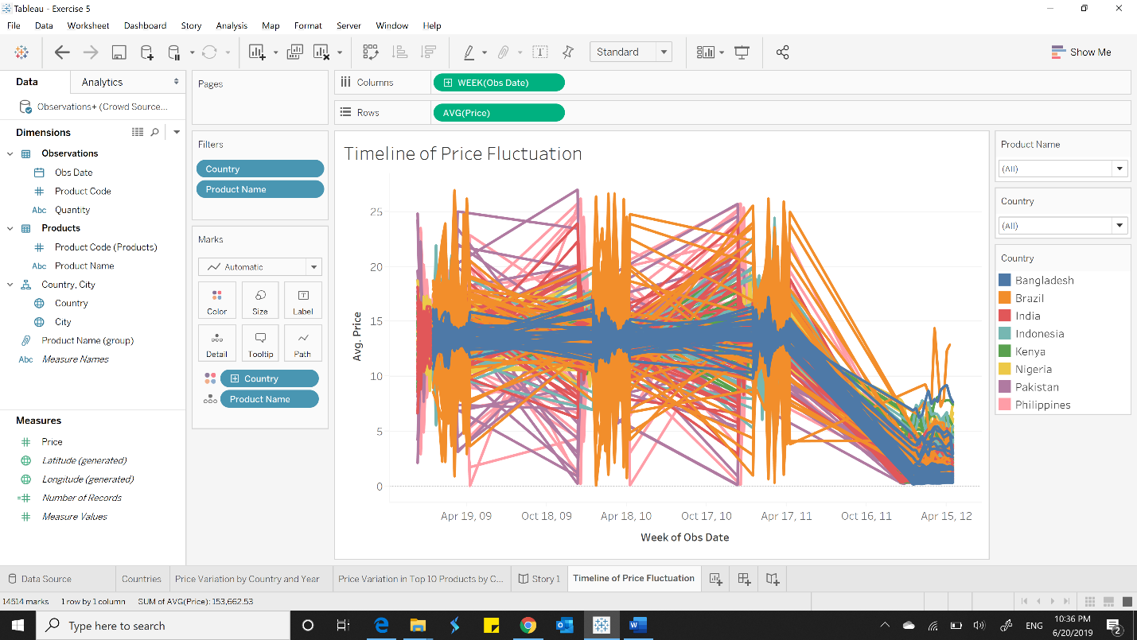

**Creating Dashboard**

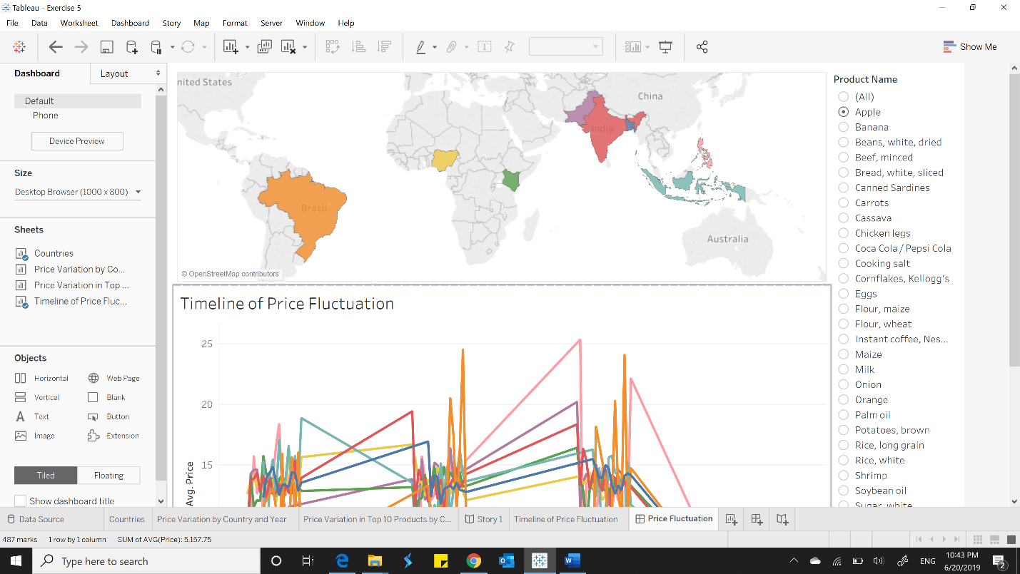

**Back on the Story**

